United States and World War 1
Historical Context | Directions:  - Watch the short clip linked below to help prepare you to further explore US involvement in World War I. To help you analyze the information in the clip, answer the questions that follow the link. Read the questions before watching the clip.  - When you are done, use the table and map to help you re-activate knowledge about World War 1.

US & World War 1 - History Channel Short Clip
Analysis Questions:

- How long did the United States watch World War 1 from afar?

- Why did immigrants come to the United States? How could this have influenced America to stay neutral in the war?

- In your opinion, what is the difference between neutrality, indifference, and empathy? Which one of these words best describes the position of the United States during the early years of World War 1?

- What was President Woodrow Wilson’s campaign slogan? Why is this ironic?

- What was the triggering event for the United States to join World War 1?

- What did Germany promise Mexico in return for aiding in the war?

- As America entered the war, who else dropped out?

- What three things did the United States contribute to the war?

Recall & Reactivate Prior Knowledge: World War 1
Part 1 - Chart: Under each term, explain what the term means and how it contributed to the start of World War 1.
Part 2 - Map: Use the map to answer the two analysis questions that follow.

Part 1

Causes of World War 1
M: Militarism

A: Alliances

N: Nationalism

I: Imperialism

A: Assassination

Part 2
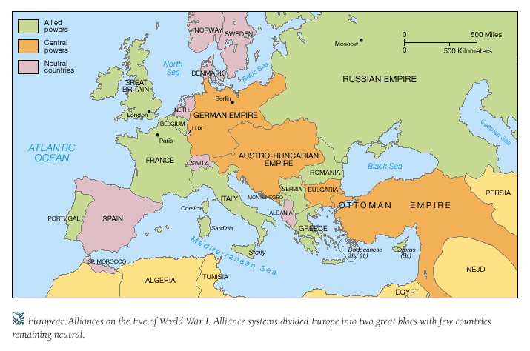
Analysis Questions:

- The United States entered on the side of the ALLIED powers. Which nations were they fighting the war alongside?

- The United States fought against the CENTRAL powers. Which nations were the United States fighting against?

