Zimmerman Telegram
Evaluating Sources
Objective | What did the Zimmerman Telegram say? Why is the sourcing information and context surrounding the Zimmerman telegram important to notice?

Document A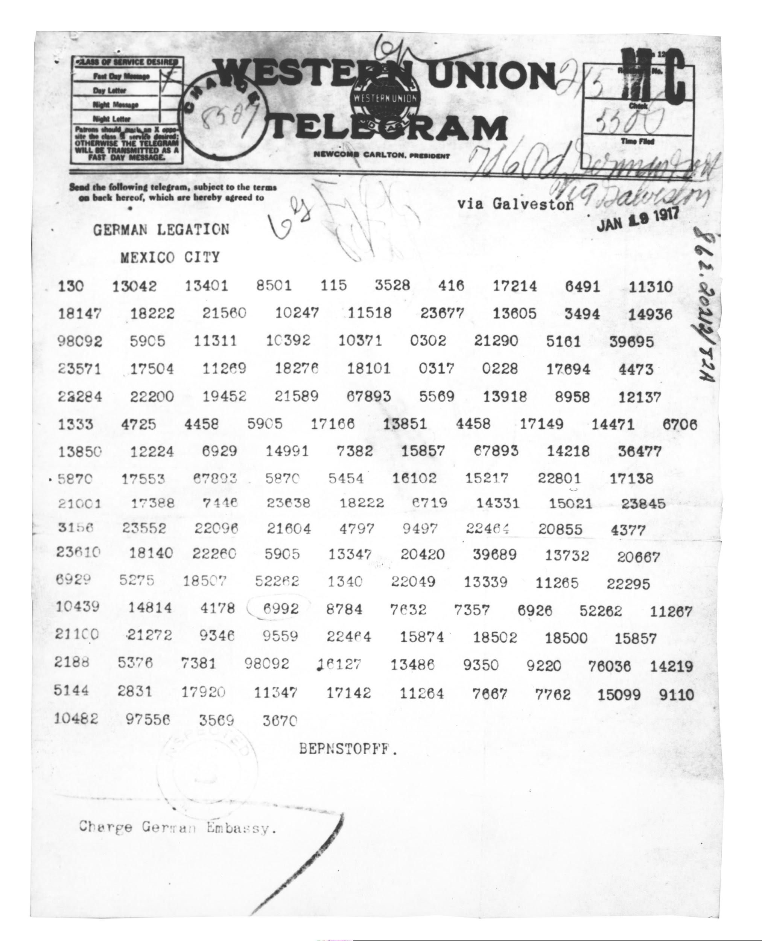

Document B

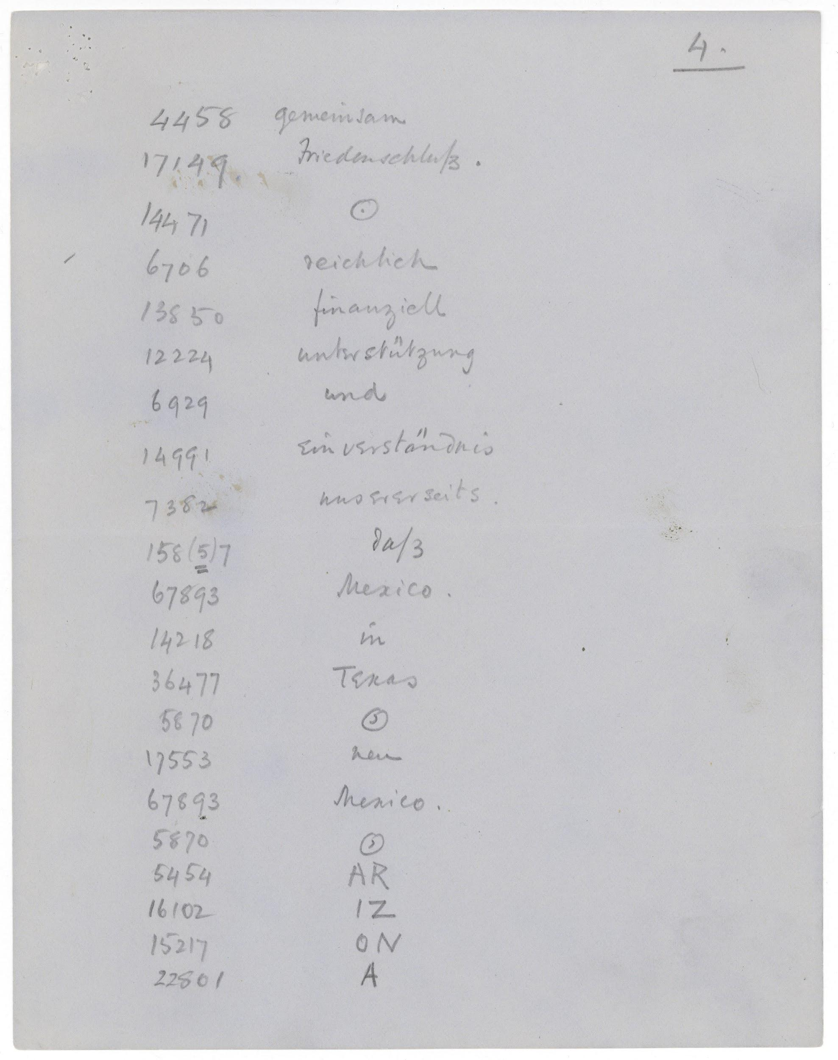

Transcript:
4  4458 gemeinsam  17149 Friedenschlutz.  14471 .[circled]  6706 reichlich  13850 finanziell  12224 unterstützung  6929 und  14991 ein verständnis  7382 unsererseits.  158(5) [?] of 3  67893 Mexico.  14218 in | 36477 Texas  5870 s  17553 nen  67893 Mexico.  5879 ,  5454 AR  16102 IZ  15217 ON  22801 A

Document C

Telegram Received from London Dated February 24th 1917 8:30 pm
Department of State

Secretary of State Washington DC,

For the PRESIDENT of the United States and the SECRETARY OF STATE of the United States from the British Government Office of the Secretary of War -

Here is the text of the coded telegram from Zimmerman, German Secretary of State for Foreign Affairs, to the German Minister of Mexico - Heinrich Von Eckhardt... I shall send you the by mail the copy of the code used in this telegram decoded into German - in the meantime, here is the English translation:

Berlin, January 19, 1917

On the first of February we intend to begin submarine warfare unrestricted. In spite of this, it is our intention to endeavor to keep neutral the United States of America.

If this attempt is not successful, we propose an alliance on the following basis with Mexico: That we shall make war together and together make peace. We shall give general financial support, and it is understood that Mexico is to reconquer the lost territory in New Mexico, Texas, and Arizona. The details are left to you for settlement....

You are instructed to inform the President of Mexico of the above deal in the greatest confidence and secrecy as soon as it is certain that there will be an outbreak of war with the United States and suggest that the President of Mexico, on his own initiative, should communicate with Japan suggesting adherence at once to this plan; at the same time, offer to mediate between Germany and Japan.

Please call to the attention of the President of Mexico that the employment of ruthless submarine warfare now promises to compel England to make peace in a few months.

Zimmerman (Secretary of State)

...The receipt of this information has so greatly alarmed the British Government that we have lost no time in communicating it to you given the threat of invasion for your territory.

Early in the war, the British Government obtained possession of a copy of the German code used in the above message, and we have made it our business to obtain copies of telegrams sent from Germany. This accounts for our ability to be able to decipher this telegram from the German Government to their representative in Mexico. This system has been guarded secretly and has only been shared with you now by the British Government in view of the extraordinary circumstances and their friendly feeling towards the United States. We request that you keep the source of the information secret but put no prohibition on the publication of the Zimmerman telegram itself…

